**Science Year 7 2022**

**Task 3 – Classification Biology Test\***

Student Name: ______________________________________________________________

Teacher: ___________________________________________________________________

Section 1: Multiple Choice ______/ 7 marks

Section 2: Short Answer _______/ 34 marks

**Total: ______/ 41 Marks %**

**Section One: Multiple choice (10 marks)**

*Select the most correct answer*

1. Out of these animals: cat, dog, bird, which is the odd one out?
2. Bird
3. Cat
4. Dog
5. A vertebrate is an animal:
6. that can fly
7. that lives on land
8. that has a backbone
9. Which of the following is **not** a member of the plant kingdom?
10. trees
11. grass
12. algae
13. What is a defining feature of mammals?
14. They have scales
15. They feed milk to their young
16. They lay eggs
17. Select the class that a snake belongs in:
18. Reptile
19. Mammal
20. Amphibian

Questions 9 and 10 refer to the dichotomous key below

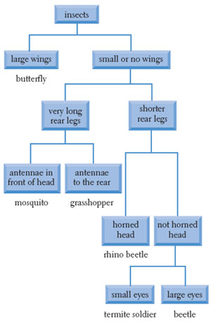

1. Which animal has the following features: small or no wings, long rear legs, and antennae to the front of their head
2. Beetle
3. Grasshopper
4. Mosquito
5. Which animal has the following features: small or no wings, short rear legs, and a horned head
6. Rhino Beetle
7. Beetle
8. Termite soldier

**Section Two: Short Answer (31 marks)**

11. Complete the characteristics of a living thing (7 marks)

M –

R –

S –

G –

R –

E –

N –

12. Write the missing levels of classification in the list below in the correct space. Use the word bank below. (4 marks)

|  |
| --- |
| Kingdom |
|  |
|  |
| Order |
|  |
| Genus |
|  |

Word bank: **Species Phylum Class Family**

12. What Kingdom are each of these species in? (3 marks)

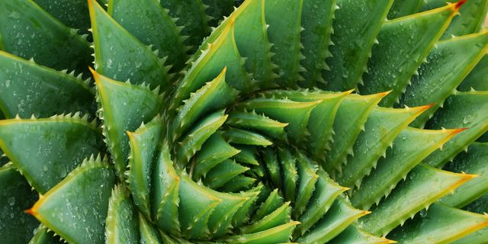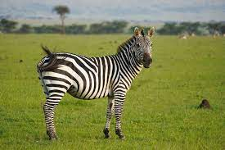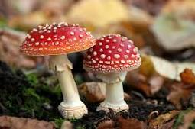

13. How do fungi get their nutrients (food)? (2 marks)

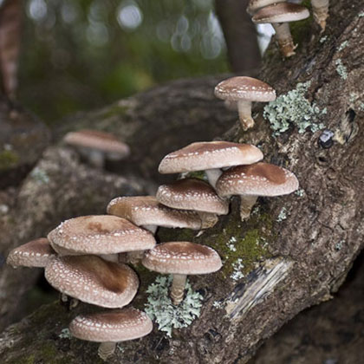

___________________________________________

___________________________________________

___________________________________________

___________________________________________

___________________________________________

___________________________________________

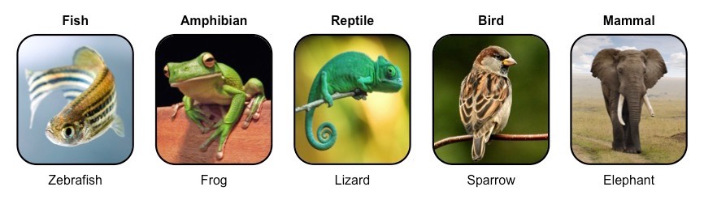14. What are the five classes of vertebrate animals? (5 marks)

B –

M –

F –

R –

A –

15. Choose one class of animal and describe what makes it different to the other classes. Make three points. (3 marks)

___________________________________________________________________________

___________________________________________________________________________

___________________________________________________________________________

___________________________________________________________________________

17. Use the dichotomous key below to answer the questions

1. What is the name of the yellow alien? ____________________________ (1 mark)
2. What is the name of the red alien? _______________________________ (1 mark)

1. Describe the features of *Alienus stripicus* (2 marks)

__________________________________________________________________________________________________________________________________________

18. Create a **branching** dichotomous key for the animals below using **physical features only**. (6 marks)

Draw your key in the space below:

‘

**End of Test**

**Finished? Check all of your answers again, then attempt this wordsearch ☺**

